Advantages of Using Artificial Intelligence in the Manufacturing Industry
Student Name: Nestor
Course: ITAI - 2372
Institution: Houston Community College
Date: April 16 2026

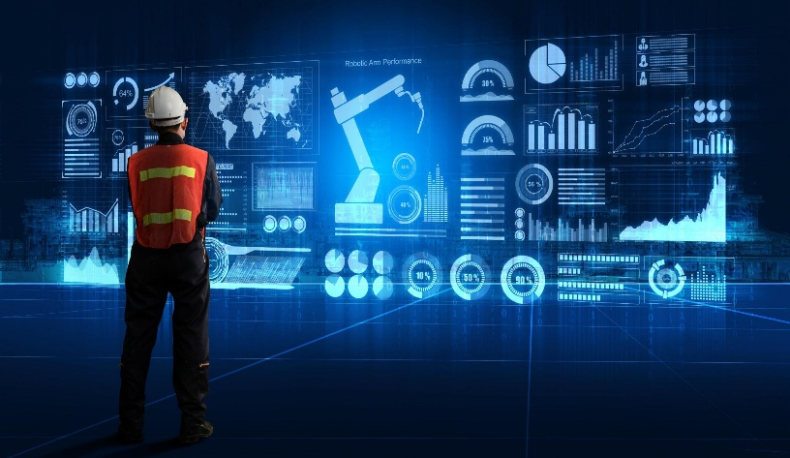
Introduction:
Artificial Intelligence (AI) is rapidly transforming the manufacturing industry by enabling smarter, more efficient, and data-driven operations. Traditionally, manufacturing relied heavily on manual processes and reactive decision-making. However, with the integration of AI technologies such as machine learning, computer vision, and predictive analytics, manufacturers can now automate complex processes, anticipate system failures, and optimize production lines in real time.
Companies like General Electric and Siemens have pioneered the adoption of AI-driven solutions, demonstrating significant improvements in operational efficiency, cost reduction, and product quality. AI is no longer a futuristic concept; it is a critical competitive advantage in modern manufacturing.
This report analyzes a real-world case study of AI implementation in manufacturing and proposes an innovative AI application to address ongoing industry challenges.
One of the most impactful uses of AI in manufacturing is predictive maintenance. General Electric (GE) implemented AI-powered predictive maintenance systems across its industrial equipment operations, particularly in aviation and energy sectors.

Problem or Challenge Addressed
Manufacturing equipment failures can lead to:
- Unexpected downtime
- High repair costs
- Production delays
- Safety risks
Traditional maintenance approaches were either:
- Reactive (fix after failure)
- Preventive (scheduled regardless of need)
Both approaches were inefficient and costly.

AI Technologies and Tools Used
GE leveraged several AI technologies, including:
- Machine Learning Algorithms
To analyze historical and real-time equipment data.
- Industrial IoT Sensors (IIoT)
To collect data such as temperature, vibration, and pressure.
- Predictive Analytics Platforms
Such as GE’s Predix platform for industrial data processing.
- Big Data Infrastructure
To process large volumes of operational data in real time.

Outcomes and Benefits Achieved
The implementation of AI-driven predictive maintenance resulted in:
- Reduced Downtime: Equipment failures decreased significantly
- Cost Savings: Lower maintenance and repair costs
- Improved Efficiency: Optimized maintenance schedules
- Enhanced Safety: Early detection of potential hazards
- Extended Equipment Lifespan: Better asset utilization
According to industry reports, predictive maintenance can reduce maintenance costs by up to 20–30% and downtime by up to 50%.

Challenges and Risks Encountered
Despite its success, GE faced several challenges:
- High Initial Investment
Implementation required significant capital for sensors and infrastructure.
- Data Quality Issues
Inaccurate or incomplete data can affect model performance.
- Integration Complexity
Integrating AI systems with legacy manufacturing systems was difficult.
- Cybersecurity Risks
Increased connectivity exposed systems to potential cyber threats.

Proposal for Innovation: AI-Driven Energy Optimization System
Overview of Proposed Solution
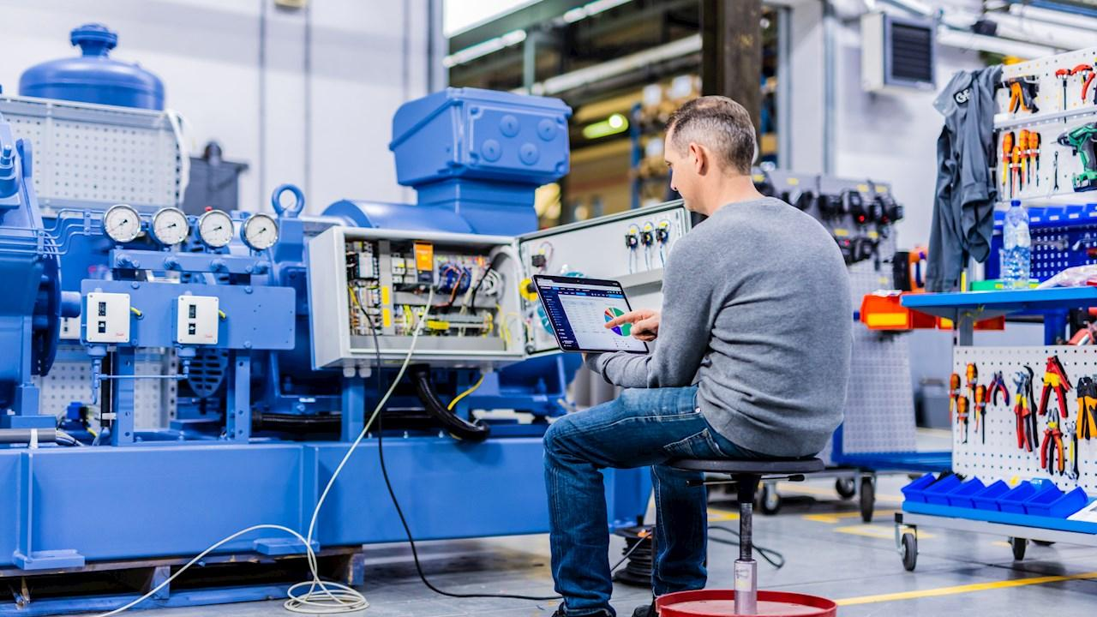
A novel application of AI in manufacturing is an AI-driven energy optimization system designed to reduce energy consumption and improve sustainability in production facilities.

Problem Being Addressed
Manufacturing plants are among the largest consumers of energy globally. Challenges include:
- High energy costs
- Inefficient energy usage
- Carbon emissions
- Lack of real-time energy monitoring

Proposed AI Solution
The system would use:
- Machine Learning Models
To predict energy demand and optimize usage.
- IoT Sensors
To monitor energy consumption across machines and systems.
- Real-Time Analytics Dashboards
To provide actionable insights to operators.
- Automated Control Systems
To adjust machine operations dynamically based on energy efficiency.

How the System Works
- Sensors collect real-time energy data
- AI analyzes patterns and identifies inefficiencies
- System predicts optimal energy usage
- Automated controls adjust operations accordingly
- Continuous learning improves performance over time

Expected Benefits
- Reduced Energy Costs: Lower electricity consumption
- Improved Sustainability: Reduced carbon footprint
- Operational Efficiency: Smarter resource allocation
- Regulatory Compliance: Easier adherence to environmental regulations

Potential Challenges
- Implementation Cost: Initial setup may be expensive
- Data Integration: Combining data from different machines
- Workforce Adaptation: Training employees to use AI systems
- System Reliability: Ensuring consistent performance

Justification of the Proposal
This solution aligns with global trends toward sustainability and smart manufacturing. As energy costs continue to rise and environmental regulations become stricter, manufacturers must adopt innovative solutions to remain competitive.
AI-driven energy optimization not only reduces operational costs but also supports long-term environmental goals, making it a strategic investment for the future.

Conclusion
Artificial Intelligence is revolutionizing the manufacturing industry by enabling smarter, more efficient, and cost-effective operations. The case study of General Electric demonstrates how AI-driven predictive maintenance can significantly reduce downtime, lower costs, and improve safety.
Furthermore, the proposed AI-driven energy optimization system highlights the potential for innovation in addressing critical challenges such as energy consumption and sustainability. While there are challenges associated with AI implementation, the long-term benefits far outweigh the risks.
As manufacturing continues to evolve, AI will play an increasingly central role in driving innovation, competitiveness, and sustainability.

References (APA Style)
Lee, J., Bagheri, B., & Kao, H. A. (2015). A cyber-physical systems architecture for industry 4.0-based manufacturing systems. Manufacturing Letters, 3, 18–23.
Wuest, T., Weimer, D., Irgens, C., & Thoben, K. D. (2016). Machine learning in manufacturing: Advantages, challenges, and applications. Production & Manufacturing Research, 4(1), 23–45.
General Electric. (2020). Predix platform and industrial AI solutions.
McKinsey & Company. (2021). The future of manufacturing: AI-driven operations.

